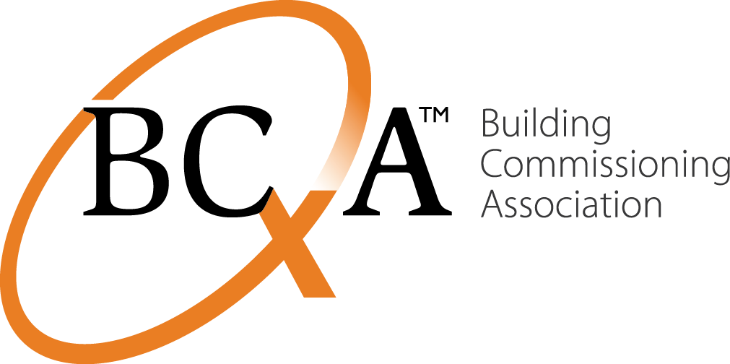
Contacts Liz Fischer  Telephone BCA: (877) 666-2292  Email lfischer@bcxa.org  Website www.bcxa.org | FOR IMMEDIATE RELEASE  December 4, 2015

BCA Scholarship Foundation Awards $2,000
Portland, ORE, December 4, 2015– The Building Commissioning Association (BCA) Scholarship Foundation today announced that Theodore James Virtue, a mechanical engineering undergraduate honor student at Georgia Institute of Technology, has been awarded a $1,000 scholarship for pursuit of further education in the field of building commissioning. The BCA Scholarship Foundation represents an educational step toward workforce development in a field that is dedicated to making commercial and institutional buildings perform as intended.
Theodore’s interest in building commissioning began with recent student co-op experience at Working Buildings, a commissioning firm in Atlanta, GA. Within the past several months he has written functional test procedures, compiled an O&M manual, and reviewed submittals on several large commercial projects. Previously, as a volunteer, he gained experience in construction practices and equipment with the Appalachia Service Project in Tennessee and West Virginia.
“Witnessing the impacts that I have on them first hand through on-site visits has been a great experience for me thus far,” says Virtue. “I can honestly say that I had no idea what commissioning was when I started my co-op at Working Buildings, but now I see the importance of the work and the impact that it can have on any project, large or small. I hope to further my knowledge of commissioning in the other two co-op semesters that I will spend at the company.”
This annual national scholarship is offered to qualified candidates who are pursuing, or plan to pursue, building commissioning as a career. The Foundation’s mission is to encourage and motivate qualified students, continuing education candidates and industry newcomers to pursue study in fields of building science including engineering, architecture, building construction, building performance, and other fields related to building commissioning.
Foundation scholarships are intended to support secondary education tuition for current students or professional development courses for individuals currently working for a firm in the business of commissioning.
The Foundation seeks applications from individuals who show promise in contributing to the commissioning profession in the future. For further information or to apply for 2016 scholarships, read more here [http://www.bcxa.org/foundation/]
About BCA
The Building Commissioning Association is dedicated to maximize the value of building commissioning to the built environment and its stakeholders. The BCA helps create, promote and provide leadership and education on current and evolving best practices in building commissioning for building owners, operators, designers, builders and commissioning providers. www.bcxa.org. The BCA Scholarship Foundation provides financial assistance to qualified candidates who aspire to shape high performance in commercial and industrial buildings.
###END###
If you would like more information about this topic, please contact Liz Fischer at BCA: (877) 666-2292 or via email: lfischer@bcxa.org

