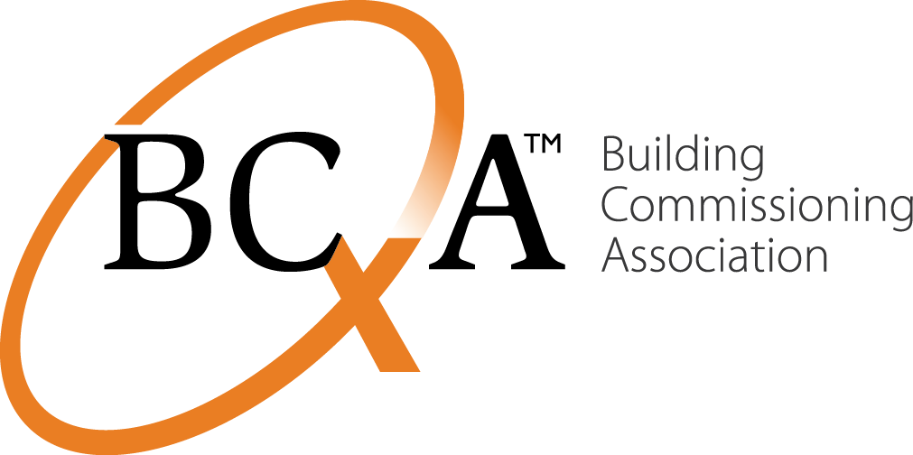
Contacts Liz Fischer  Telephone BCA: (877) 666-2292  Email lfischer@bcxa.org  Website www.bcxa.org | FOR IMMEDIATE RELEASE  January 27, 2015

Move Over, A/E/Cs: Quality-Based Selection is for Everyone

Portland, ORE, January 27, 2015– The International Board of the Building Commissioning Association (BCA) is pleased to announce a new industry paper advocating Qualifications-Based Selection (QBS) for the commissioning profession. QBS is an approach to evaluating and selecting professionals based on competence – and evidence.
Until now the QBS process, defined in the Congressional Brooks Act of 1972, has applied mainly to architects and engineers. The BCA advocates that QBS be adopted by commissioning professionals and all building owners, managers and project teams who hire them.
When owners don’t use QBS to verify commissioning capabilities and experience, pricing usually becomes the default. Owners do need to struggle with tradeoffs when allocating project costs, especially in the public sector where the “public good” (i.e., your tax dollars) is a decision element. Lowest bid is not the answer for buildings that work.
Low-bid selection results in a lower investment in delivering quality services, especially if services are not clearly defined. Costs of project-wide services and products often rise as the project progresses due to change orders and errors or omissions in planning, design, construction and/or delivery. To begin building projects with more accurate and predictable budgets, owners need to understand and use the QBS process as their tool for managing the triad of cost, schedule and quality.
Commissioning is the continuous quality assurance link across disciplines and schedule in a building project. It should be regarded by owners as one of the most important services to be hired based on qualifications. The BCA strongly endorses and recommends the use of QBS by owners and commissioning providers to accelerate quality commissioning and high performance in commercial buildings.
About BCA
The Building Commissioning Association is dedicated to maximize the value of building commissioning to the built environment and its stakeholders. The BCA helps create, promote and provide leadership and education on current and evolving best practices in building commissioning for building owners, operators, designers, constructors and commissioning providers. www.bcxa.org.
###END###
If you would like more information about this topic, please contact Liz Fischer at BCA: (877) 666-2292 or via email: lfischer@bcxa.org

