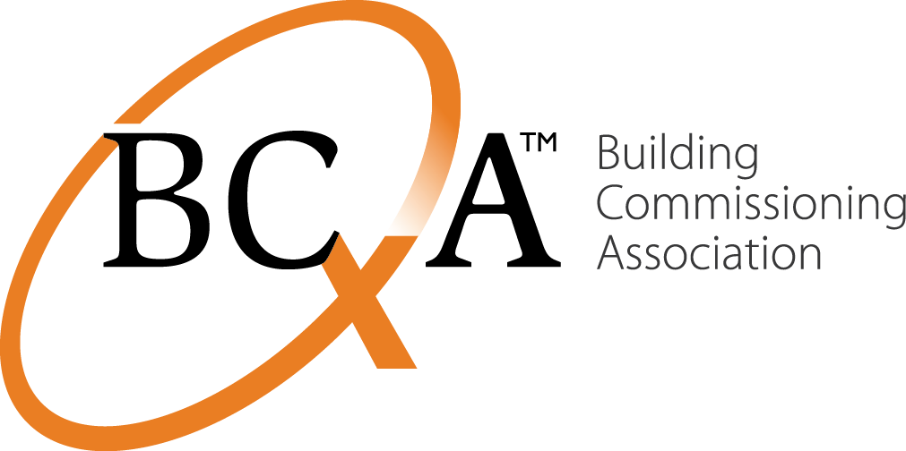

Contacts Liz Fischer  Telephone BCxA: (877) 666-2292  Email lfischer@bcxa.org  Website www.bcxa.org | FOR IMMEDIATE RELEASE  January 25, 2016

BCxA Expands Building Science/Commissioning Education Program
Portland, ORE, January 25, 2016– The Building Commissioning Association (BCxA) has successfully negotiated with CLEAResult, a national energy services and consulting firm, for licensure of its online commissioning training program formerly known as, “Commissioning Authority and Commercial Energy Auditor” (CxA/CEA).
The newly revised BCxA program, leading to AIA-approved continuing education credits and a Commissioning Provider (CxP) Certificate, fills the gap in professional education by offering intensive courses as both as an a la carte program, and a career-focused sequence of online education with a hands on Laboratory.
The program provides deeper building science, analysis and performance education than is currently offered at the collegiate level. It is the only program of its kind in the private sector that supports professional development in the growing field of commissioning.
CLEAResult’s acquisition of PECI in 2014 paved the way for the program to be licensed to BCxA as an original author. BCxA’s education arm, BCxA University (www.bcxauniversity.org), will carry on the quality training program as a core part of its mission to provide intensive, hands-on commissioning education and growth opportunities.
The program was originally designed by PECI and BCxA through a grant from the U.S. Department Energy and co-funding from NYSERDA, California Energy Commission, Northwest Energy Efficiency Alliance, California Commissioning Collaborative and the BCxA. The curriculum includes three modules of online learning – fundamentals of new construction and existing building commissioning, systems and assemblies, and systems performance and analysis – and culminates in a 40-hour classroom lab and a certificate of completion.
With the addition of the CxP Program to BCxA’s education portfolio, BCxA University continues to expand the scope of classroom, webinar and online learning opportunities for new entrants and seasoned professionals associated with the field of commissioning.
Learn more, check out the catalog, and get started by registering at www.bcxauniversity.org.
About BCxA
The Building Commissioning Association is dedicated to maximizing the value of building commissioning to the built environment and its stakeholders. The BCxA helps create, promote and provide leadership and education on current and evolving best practices in building commissioning for building owners, operators, designers, constructors and commissioning providers. www.bcxa.org.
###END###

