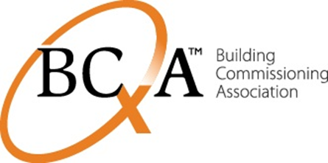
Application/Nomination Form
2021 Elections –Chapter Boards of Directors
Term: January 1, 2021 – December 31, 2022

Must be completed by potential candidate

Name:
Title:
Organization:
Address:
Telephone:
Fax:
Email:

CHAPTER: _____________________________________________________________
This information is for the Nomination Committee only and will NOT be shared outside the committee.

1. What resources could you contribute to help increase BCxA membership from high-priority sectors including: building owners, builders and contractors, product manufacturers, finance community, utilities, universities, and state and local governments?

2. One of the important functions of Chapter Board Members is to support the goals of both the Chapter and the Association. This may include phone calls to potential sponsors for events, identifying potential speakers or other resources for Chapter programs or initiatives, helping recruit members, and actively participating in meetings, etc. Please explain your experience and willingness to provide leadership in these ways.

3. The Chapter Board has identified strategic areas for development, including growing membership, increasing the number of Certified Commissioning Professionals, continuing education, coordinating with allied organizations (such as ASHRAE, AIA, and BOMA), membership development, marketing/communications, and finance. Please indicate which of these areas you have an interest in and list any expertise in participating in such efforts.

4. What refinements or larger changes would you suggest the Association consider?

5. Are you able to attend (via teleconference) monthly Chapter Board meetings? Are you able to attend the annual Leadership Retreat and BCxA Conference?

THE FOLLOWING ARE REQUIRED FOR CONSIDERATION AS A CANDIDATE:

1. Responses to the questions above.

2. A biographical statement of up to 400 words that will be attached to the ballot if you are selected by the Nominating Committee as a candidate.

3. A professional resume for use by the Nominating Committee in reviewing potential candidates.

4. Signed Conflict of Interest Statement, Antitrust Policy, Chapter Board Member Commitment.

Please submit forms by September 30, 2020 to:
Nominating Committee, BCA, 1600 NE Compton Dr., #200, Hillsboro, OR 97006
Or Via EMAIL to: sadams@bcxa.org

